https://www.geeksforgeeks.org/process-table-and-process-control-block-pcb/?ref=rp
While creating a process the operating system performs several operations. To identify the processes, it assigns a process identification number (PID) to each process. As the operating system supports multi-programming, it needs to keep track of all the processes. For this task, the process control block (PCB) is used to track the process’s execution status. Each block of memory contains information about the process state, program counter, stack pointer, status of opened files, scheduling algorithms, etc. All these information is required and must be saved when the process is switched from one state to another. When the process makes a transition from one state to another, the operating system must update information in the process’s PCB.
A process control block (PCB) contains information about the process, i.e. registers, quantum, priority, etc. The process table is an array of PCB’s, that means logically contains a PCB for all of the current processes in the system.
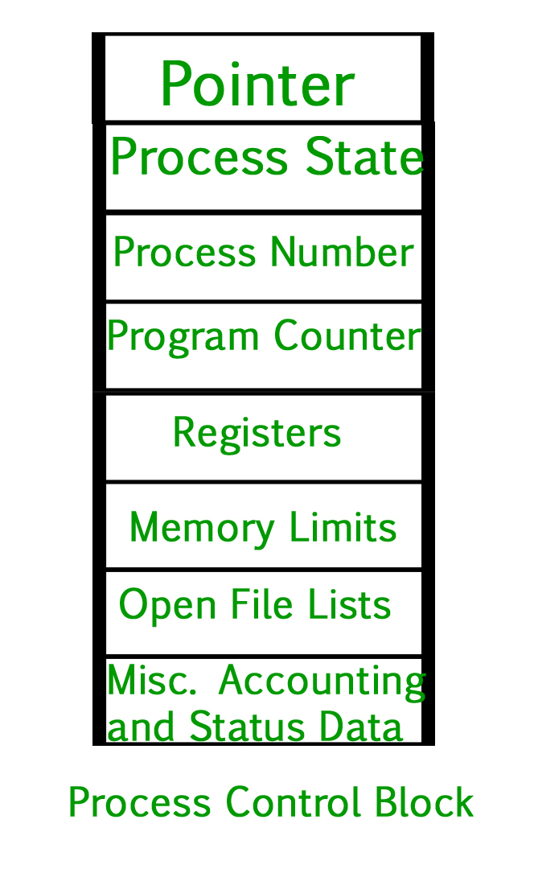
- Pointer – It is a stack pointer which is required to be saved when the process is switched from one state to another to retain the current position of the process.
- Process state – It stores the respective state of the process.
- Process number – Every process is assigned with a unique id known as process ID or PID which stores the process identifier.
- Program counter – It stores the counter which contains the address of the next instruction that is to be executed for the process.
- Register – These are the CPU registers which includes: accumulator, base, registers and general purpose registers.
- Memory limits – This field contains the information about memory management system used by operating system. This may include the page tables, segment tables etc.
- Open files list – This information includes the list of files opened for a process.
Miscellaneous accounting and status data – This field includes information about the amount of CPU used, time constraints, jobs or process number, etc.
The process control block stores the register content also known as execution content of the processor when it was blocked from running. This execution content architecture enables the operating system to restore a process’s execution context when the process returns to the running state. When the process makes a transition from one state to another, the operating system updates its information in the process’s PCB. The operating system maintains pointers to each process’s PCB in a process table so that it can access the PCB quickly.
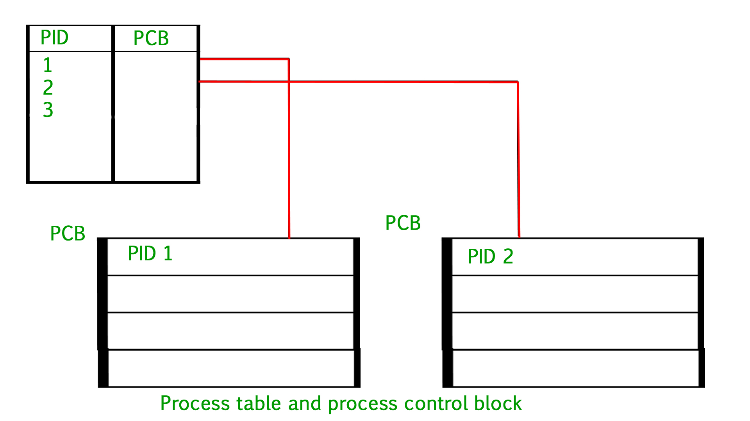
Thread in Operating System
- Difficulty Level : Medium
- Last Updated : 16 Aug, 2019
What is a Thread?
A thread is a path of execution within a process. A process can contain multiple threads.
Why Multithreading?
A thread is also known as lightweight process. The idea is to achieve parallelism by dividing a process into multiple threads. For example, in a browser, multiple tabs can be different threads. MS Word uses multiple threads: one thread to format the text, another thread to process inputs, etc. More advantages of multithreading are discussed below
Process vs Thread?
The primary difference is that threads within the same process run in a shared memory space, while processes run in separate memory spaces.
Threads are not independent of one another like processes are, and as a result threads share with other threads their code section, data section, and OS resources (like open files and signals). But, like process, a thread has its own program counter (PC), register set, and stack space.
Advantages of Thread over Process
1. Responsiveness: If the process is divided into multiple threads, if one thread completes its execution, then its output can be immediately returned.
2. Faster context switch: Context switch time between threads is lower compared to process context switch. Process context switching requires more overhead from the CPU.
3. Effective utilization of multiprocessor system: If we have multiple threads in a single process, then we can schedule multiple threads on multiple processor. This will make process execution faster.
4. Resource sharing: Resources like code, data, and files can be shared among all threads within a process.
Note: stack and registers can’t be shared among the threads. Each thread has its own stack and registers.
5. Communication: Communication between multiple threads is easier, as the threads shares common address space. while in process we have to follow some specific communication technique for communication between two process.
. Enhanced throughput of the system: If a process is divided into multiple threads, and each thread function is considered as one job, then the number of jobs completed per unit of time is increased, thus increasing the throughput of the system.
Types of Threads
There are two types of threads.
User Level Thread
Kernel Level Thread
Refer User Thread vs Kernel Thread for more details.
Below are previous years’ gate questions on threads:
http://quiz.geeksforgeeks.org/gate-gate-cs-2011-question-16/
http://quiz.geeksforgeeks.org/gate-gate-cs-2007-question-17/
http://quiz.geeksforgeeks.org/gate-gate-cs-2014-set-1-question-30/
Multithreading in C
- Difficulty Level : Medium
- Last Updated : 10 Oct, 2018
What is a Thread?
A thread is a single sequence stream within in a process. Because threads have some of the properties of processes, they are sometimes called lightweight processes.
What are the differences between process and thread?
Threads are not independent of one other like processes as a result threads shares with other threads their code section, data section and OS resources like open files and signals. But, like process, a thread has its own program counter (PC), a register set, and a stack space.
Why Multithreading?
Threads are popular way to improve application through parallelism. For example, in a browser, multiple tabs can be different threads. MS word uses multiple threads, one thread to format the text, other thread to process inputs, etc.
Threads operate faster than processes due to following reasons:
1) Thread creation is much faster.
2) Context switching between threads is much faster.
3) Threads can be terminated easily
4) Communication between threads is faster.

See http://www.personal.kent.edu/~rmuhamma/OpSystems/Myos/threads.htm for more details.
Can we write multithreading programs in C?
Unlike Java, multithreading is not supported by the language standard. POSIX Threads (or Pthreads) is a POSIX standard for threads. Implementation of pthread is available with gcc compiler.
A simple C program to demonstrate use of pthread basic functions
Please note that the below program may compile only with C compilers with pthread library.
filter_none
brightness_4
#include <stdio.h>
#include <stdlib.h>
#include <unistd.h> //Header file for sleep(). man 3 sleep for details.
#include <pthread.h>

// A normal C function that is executed as a thread
// when its name is specified in pthread_create()
void *myThreadFun(void *vargp)
{
sleep(1);
printf("Printing GeeksQuiz from Thread \n");
return NULL;
}

int main()
{
pthread_t thread_id;
printf("Before Thread\n");
pthread_create(&thread_id, NULL, myThreadFun, NULL);
pthread_join(thread_id, NULL);
printf("After Thread\n");
exit(0);
}

In main() we declare a variable called thread_id, which is of type pthread_t, which is an integer used to identify the thread in the system. After declaring thread_id, we call pthread_create() function to create a thread.
pthread_create() takes 4 arguments.
The first argument is a pointer to thread_id which is set by this function.
The second argument specifies attributes. If the value is NULL, then default attributes shall be used.
The third argument is name of function to be executed for the thread to be created.
The fourth argument is used to pass arguments to the function, myThreadFun.
The pthread_join() function for threads is the equivalent of wait() for processes. A call to pthread_join blocks the calling thread until the thread with identifier equal to the first argument terminates.
How to compile above program?
To compile a multithreaded program using gcc, we need to link it with the pthreads library. Following is the command used to compile the program.
gfg@ubuntu:~/$ gcc multithread.c -lpthread
gfg@ubuntu:~/$ ./a.out
Before Thread
Printing GeeksQuiz from Thread
After Thread
gfg@ubuntu:~/$
A C program to show multiple threads with global and static variables
As mentioned above, all threads share data segment. Global and static variables are stored in data segment. Therefore, they are shared by all threads. The following example program demonstrates the same.
filter_none
brightness_4
#include <stdio.h>
#include <stdlib.h>
#include <unistd.h>
#include <pthread.h>

// Let us create a global variable to change it in threads
int g = 0;

// The function to be executed by all threads
void *myThreadFun(void *vargp)
{
// Store the value argument passed to this thread
int *myid = (int *)vargp;

// Let us create a static variable to observe its changes
static int s = 0;

// Change static and global variables
++s; ++g;

// Print the argument, static and global variables
printf("Thread ID: %d, Static: %d, Global: %d\n", *myid, ++s, ++g);
}

int main()
{
int i;
pthread_t tid;

// Let us create three threads
for (i = 0; i < 3; i++)
pthread_create(&tid, NULL, myThreadFun, (void *)&tid);

pthread_exit(NULL);
return 0;
}

gfg@ubuntu:~/$ gcc multithread.c -lpthread
gfg@ubuntu:~/$ ./a.out
Thread ID: 3, Static: 2, Global: 2
Thread ID: 3, Static: 4, Global: 4
Thread ID: 3, Static: 6, Global: 6
gfg@ubuntu:~/$
Please note that above is simple example to show how threads work. Accessing a global variable in a thread is generally a bad idea. What if thread 2 has priority over thread 1 and thread 1 needs to change the variable. In practice, if it is required to access global variable by multiple threads, then they should be accessed using a mutex.
References:
http://www.csc.villanova.edu/~mdamian/threads/posixthreads.html
Computer Systems : A Programmer
http://php.kambing.ui.ac.id/manual/en/function.chmod.php

